

Pokhara University Affiliated

**LA GRANDEE INTERNATIONAL COLLEGE**

**Simalchaur, Pokhara**

Mid Term Project Report On

JobMinis

**Submitted to:**

LA Grandee International College

Bachelor of Computer Application (BCA) Program

In partial fulfillment of the degree of BCA affiliated under Pokhara University

**Submitted By:**

Sapna Baniya Kriti Subedi. Aastha Shrestha Deepa Chhetri

BCA, 6th semester BCA, 6th semester BCA, 6th semester. BCA, 6th semester

2018-1-53-0129 2018-1-53-0112. 2018-1-53-0102 2018-1-53-0108

Date: June-24, 2022

**ACKNOWLEDGEMENT**

We express our sincere regard to our project supervisor Mr sunil pandey, for his valuable time, guidance, encouragement, support and cooperation throughout our project. We would sincerely like to thank BCA Department for allowing us to work on enhancing our technical skills while undergoing this project. This project helped in understanding the various parameters which are involved in the development of a web application and the working and integration of the front end along with the back end to create a fully functional.

We would also like to thank Pokhara University for designing such a worthy syllabus and making us do this project. Our next batch of thanks goes to the Lagrandee International College without whose help our project would have been impossible.

With Regards,

Sapna Baniya (Roll No: 19530229)

Deepa Chhetri (Roll No: 19530108 )

Kriti Subedi (Roll No: 19530112 )

Astha Shrestha (Roll No: 19530221)

Abstract

JOB SEARCH PORTAL

It can be difficult for job seekers to find positions that best match their interests and skill set. The challenges stem from a lack of understanding of the organization's mission, workplace culture, and open positions. Additionally, finding the ideal individual with the required qualifications to fill their open positions is a crucial duty for every organization's recruiters. Online job search portals have undoubtedly improved both parties' convenience when looking for work. The answer is a job portal, which brings together recruiters and job seekers with the goal of satisfying each party's specific needs. They are the quickest and cheapest means of communication, regardless of the distance between audiences they can reach with a single click. Find The web application "Job Search Portal" offers a simple and practical search application so that both recruiters and job searchers can locate the ideal individual. Anyone looking for work can search the available positions. Job searchers can update their information and skill set by registering with the application. They can look for open vacancies and submit applications for them

# Table Of Content

Table Of Content 4

Introduction: 5

Problem Statement 8

Analysis: 9

Requirement Gathering: 9

Requirement Specifications: 9

Software Requirements: 9

Minimum Hardware Requirements: 9

Feasibility study: 9

Operational Feasibility: 9

Technical Feasibility: 9

Economical Feasibility 9

Objective 10

Methodology 11

Design 12

Data Flow Diagram 12

DFD-0 12

DFD-1 13

DFD-2 14

FlowChart 16

Class Diagram 18

ER Diagram 19

Deliverables 20

Time Schedule/ Gant Chart 21

Testing 22

Documentation 23

Conclusion 23

Future Work 23

References 24

# Introduction:

JobMinis is a system for an online job board that assists companies to find qualified applicants and job seekers to find suitable jobs. These online employment portals provide a diverse selection of opportunities in several fields. Online employment portals have been built by government agencies, non-profit organizations, colleges, and private corporations to allow job seekers to access the organizations' websites. Nonetheless, it may not completely satisfy job hunters and job ads. Normally, many businesses squander money and effort trying to locate the best people for open positions. Even though certain websites provide particular information on CVs and how to write them, they do better in interviews and on issues that the interviewer like.

In this project, we designed an open-source software platform to be used as a job portal system by companies, agencies, and freelancing organizations. It provides a platform for employers and job seekers to communicate effectively. JobMinis is a web application that allows job seekers to find available job openings and employers to identify qualified job candidates to select the best ones. The only way to choose the best-qualified candidate is to have a pool of suitable applications, which may be achieved by attracting people to the market. JobMinis is ideal for this purpose.

Employers and job seekers alike have come to rely on e-recruitment to achieve their respective goals. Traditional recruitment strategies include job fairs, university career employment services, employee recommendations, newspaper and television advertisements, and so on. E-recruitment has altered the way firms and applicants search for jobs as technology has advanced and internet usage has grown. The recruiting process is sped up at every level with the use of online job search portals, from job advertisements to candidate applications to interviewing process. When compared to traditional advertising, the cost of searching for/posting jobs will be significantly lower. Employers can use a job search site to advertise job openings, responsibilities, and qualifications to attracters. Job seekers can use the portal to search for positions in firms, organizations, and places they might not have known about otherwise. Furthermore, candidates/employers can submit an evaluation of an organization, which may assist them in making changes.

Background Study

We started the investigation by identifying the need for job seeker and company. Initially, we bounded our research to find the wide reason that emerges the require of Job. The techniques we used were visiting an online website that is presented as the templates. We collected several requirements for the project from our primitive research, website visits and interview with the concerned personnel and their experiences regarding the concepts of its development. Mostly the following influences enforce us to design Job Search website: - • The easy way of choosing candidates • Uncomplicated Resume Research • Promote Company’s Name After analyzing the software of Department of Computer Science College of Engineering students of Kathmandu where they have developed a job search portal as a final year project by studying their report, we have found to know that they have used Microsoft SQL Server, PHP as development tools. Its main aim is to make a system that is easily managed and can be secured and to cover all the areas of Job. we designed a project “Online Job Portal system" and all its application codes are in PHP with the AJAX and JQUERY backend. This portal provides all the features with the provision of extension JS-JOB Plug-in. The plugin, we are using is free trial, so its functionalities are limited. This project gratifies all the functional requirements mentioned in the project. Job Portal was built with the vision of democratizing recruitment software, and the mission to transform the way companies recruit on a global scale. Following this vision, we designed an intuitive, fun, and easy-to-use AI-powered platform to streamline and optimize the entire recruitment process.[1] Job Portal is to boost candidate applications by posting your jobs on thousands of free and premium channels globally such as Indeed, Monster, LinkedIn, Facebook, Google for Jobs, and many more. Manages all our job and campaigns directly within job portal while saving money.[2]

# Problem Statement

Our current system is entirely manual. Jobseekers might all work on paper in a manual system, making it an extremely time-consuming process. When more members are added, the amount of paperwork increases automatically. Because the companies are linked, all job searches will be done manually. The job seeker who is looking for a specific position. It is difficult to locate according to the requirements.

* People have to visit different places for the jobs which is much time consuming and costly
* It is not easy for job seeker to apply for a specific job he/she wants because the job description sometimes may not cover everything.
* Many new graduates, who become unemployed because they do not have the job skills needed
* Inappropriate company description.

We conducted a survey to collect data of problems and experiences of various people regarding current job portals. The survey link is as follows:

[https://docs.google.com/forms/d/e/1FAIpQLSeomiglrw4RcsD7WPDv1PcCnP18mhSLeSabwDg2TLhHlHic-A/viewform?usp=sf_link](https://docs.google.com/forms/d/e/1FAIpQLSeomiglrw4RcsD7WPDv1PcCnP18mhSLeSabwDg2TLhHlHic-A/viewform?usp=sf_link&fbclid=IwAR2UknU-VFI7tacZwqIrXBuuZfSou53nQCCDaFr6xeo3F21AS4FgrIWm0eo)

# Analysis:

## Requirement Gathering:

Requirement Analysis is the first and most important step in the website development activity for building a robust and user-friendly website. We have started working on determining the functionalities that the application should provide. We have done a good amount of research on existing systems and their disadvantages. Also we have analyzed some reviews of people regarding the existing job portals.

### Requirement Specifications:

Below are the technical requirements to develop the Job Search Portal application

### Software Requirements:

* Operating System
* Database: MySQL
* Front End: HTML5, CSS3, JavaScript, jQuery
* Back End: PHP
* Browser: Chrome or Firefox or Internet Explorer

### Minimum Hardware Requirements:

* Processor: Intel core i3+
* Processor speed: 2.40 GHz
* RAM: 8 GB

## Feasibility study:

It is essential to evaluate the feasibility of a project at the earliest possible time to avoid any future complications. There are various ways of checking whether a system is feasible or not. The following feasibility studies were performed to gauge the feasibility of our website:

### Operational Feasibility:

It has been noted that the proposed website will be quite user-friendly, and because it will be constructed with adequate assistance, even people with limited windows expertise may easily use it.

### Technical Feasibility:

In this test, we examined the function, performance, and limitations that might impair the development of our system. For this we did a detailed assessment of the technical viability of our system.

Economical Feasibility: We determined how much it will cost to create the planned system in relation to the eventual revenue or advantage that would result from its development. The income can be in terms of money or goodwill, since the software brings in both, the system will be highly viable.

# Objective

The major goals of this project are as follows:

* Create a dynamic job hub website.
* To provide a common platform for both job seekers and job provide to share their knowledge and experience.
* make easy for employer and job seeker to search job and information

# Methodology

In this project ,we are using Iterative model to develop our project.

The diagram of iterative model is shown below:-

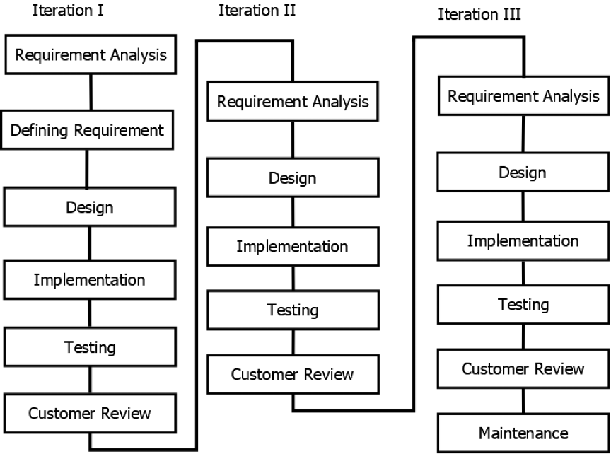

## Design

### Data Flow Diagram

#### DFD-0

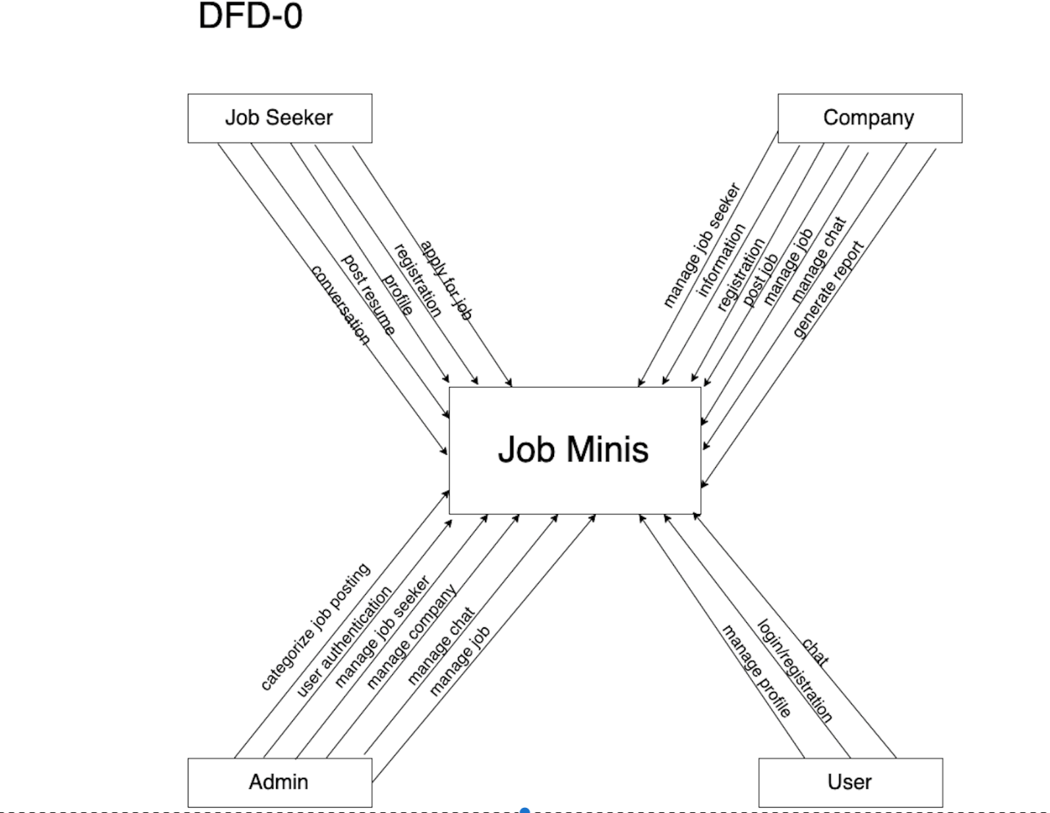

#### DFD-1

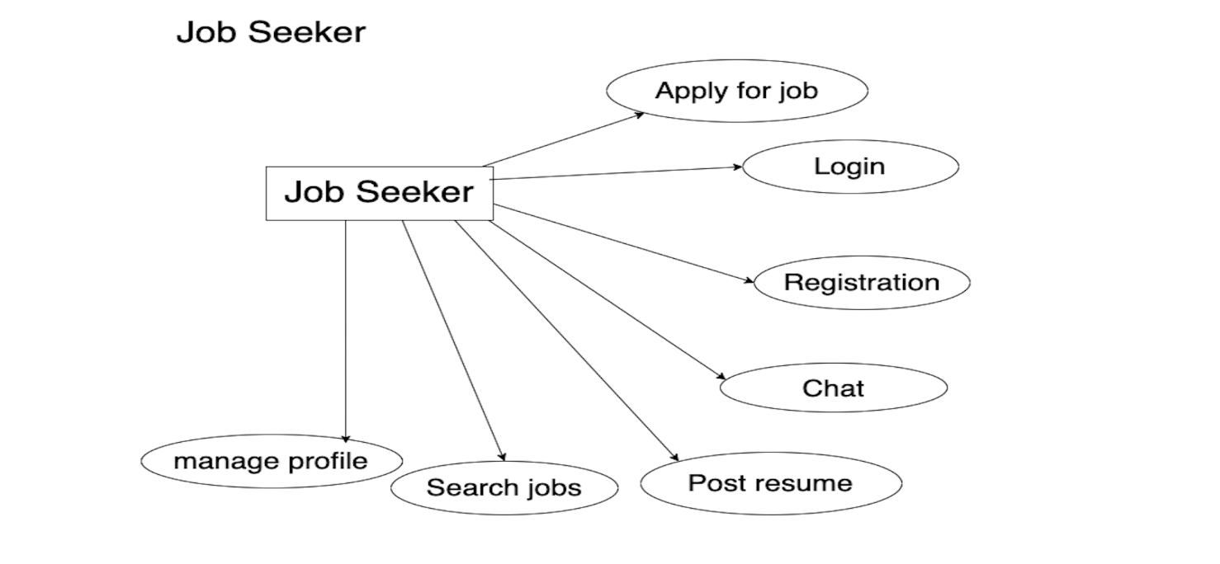

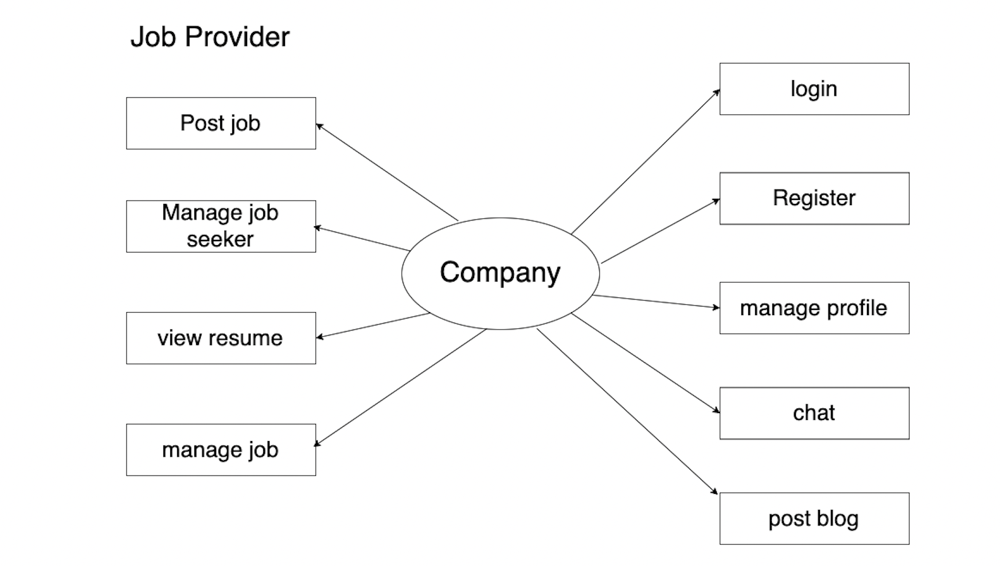

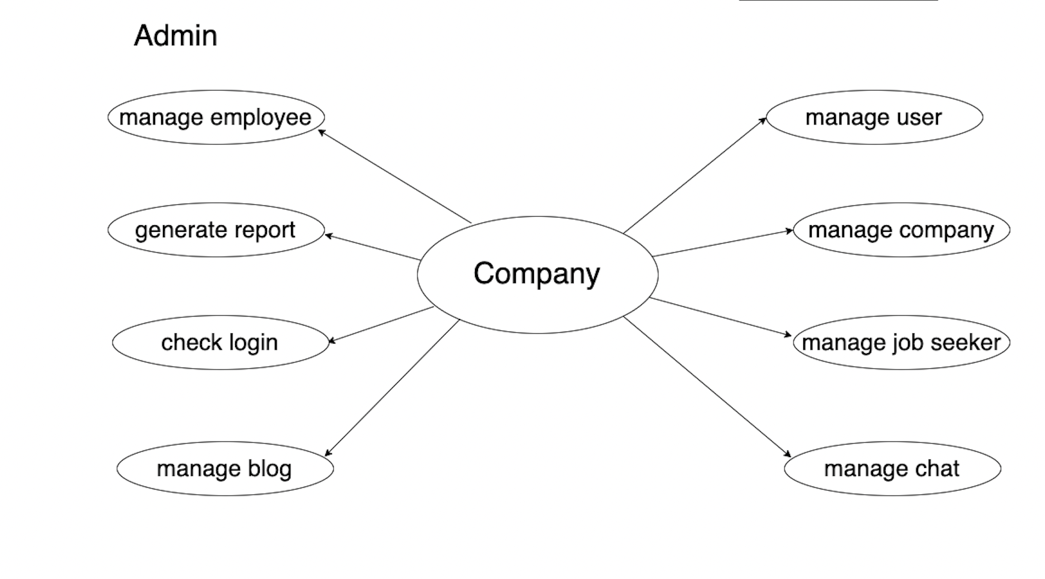

#### DFD-2

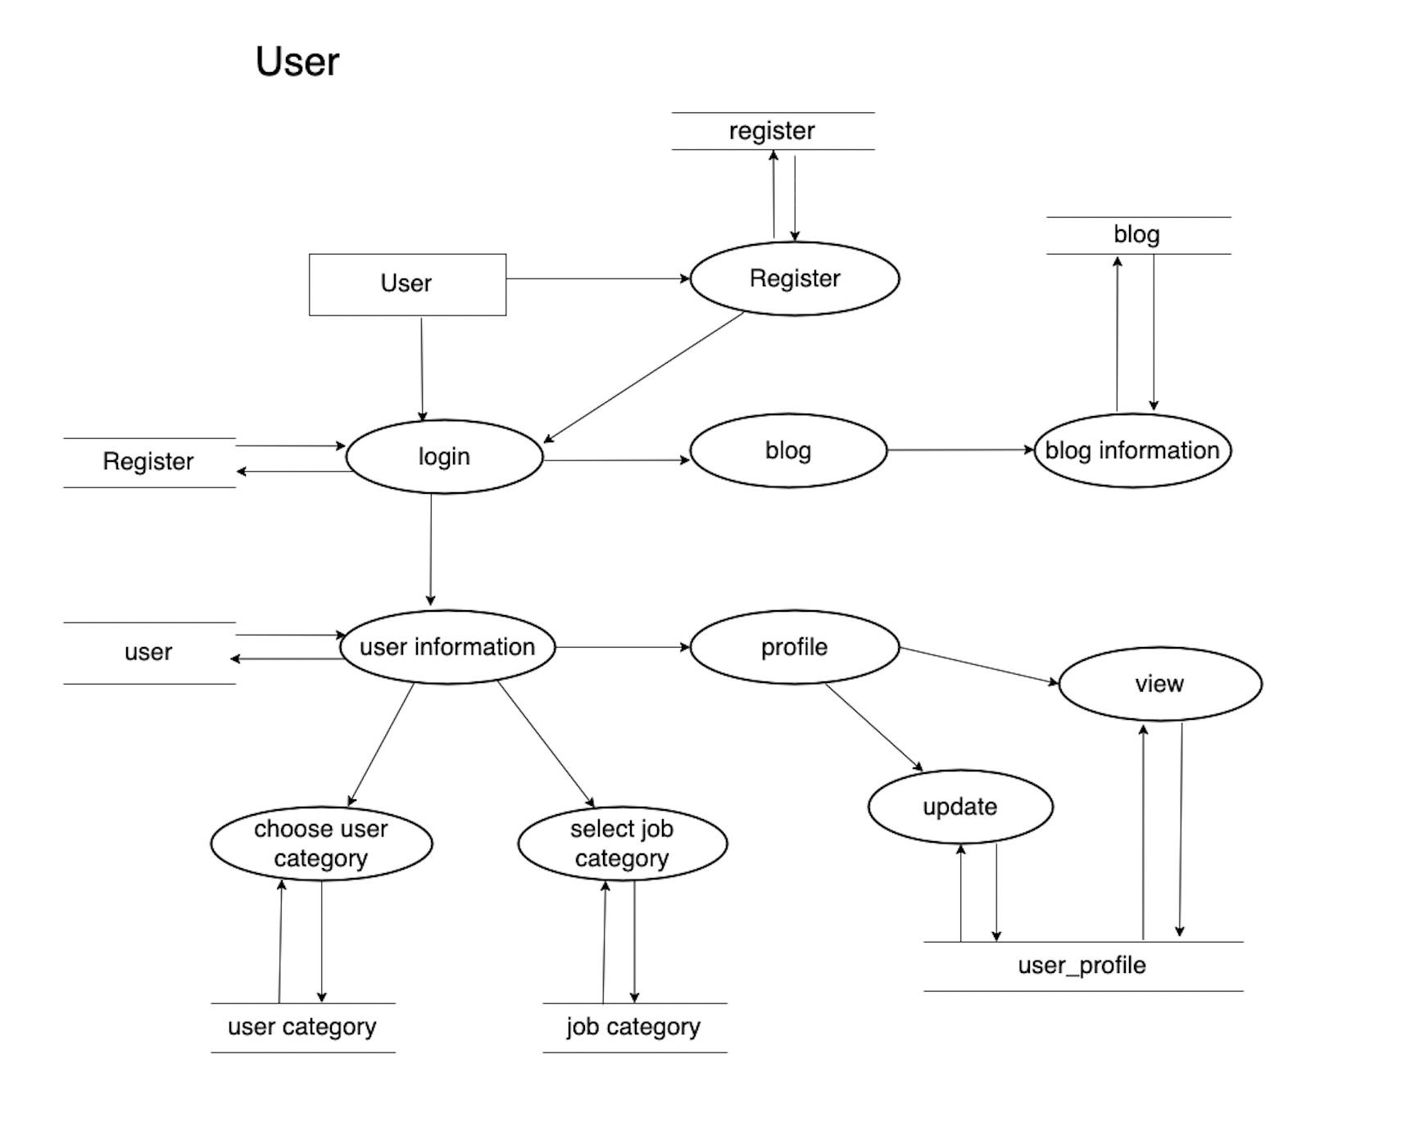

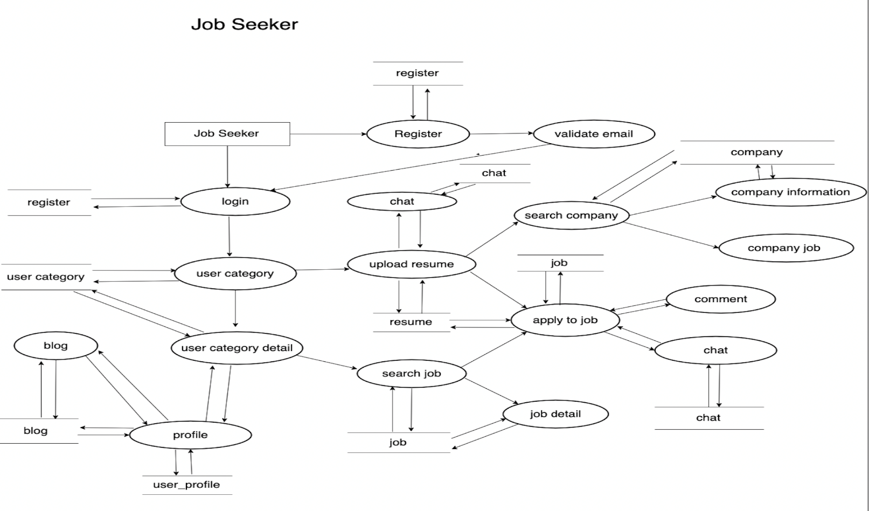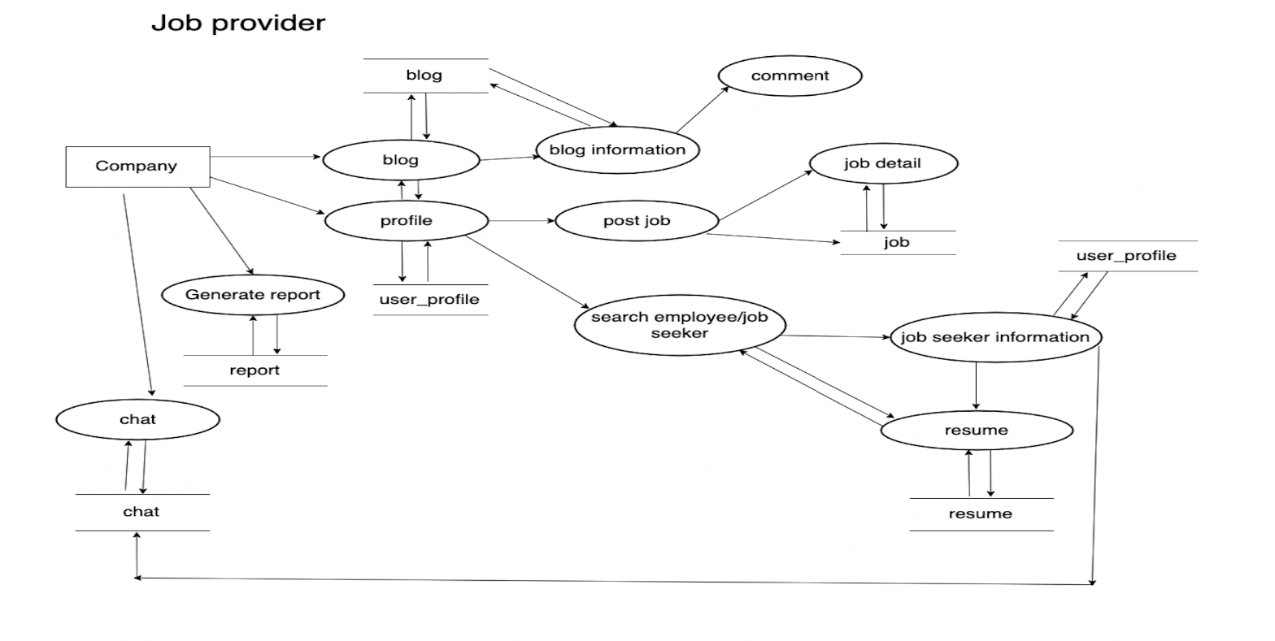

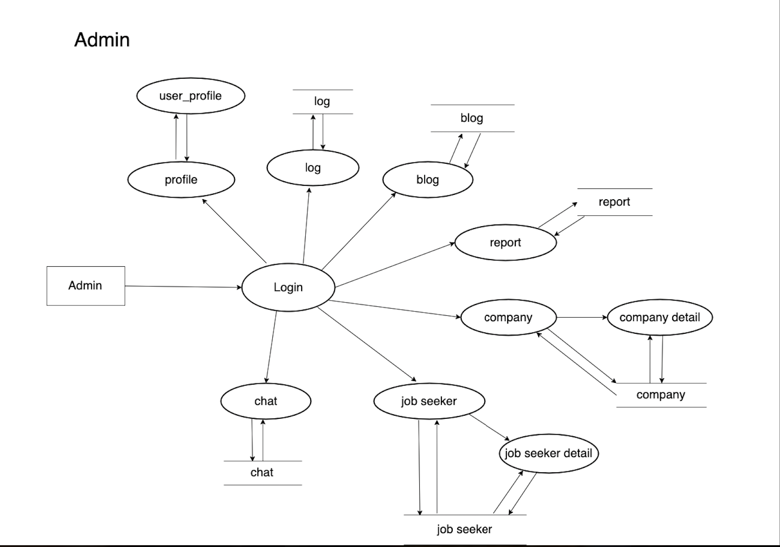

### FlowChart

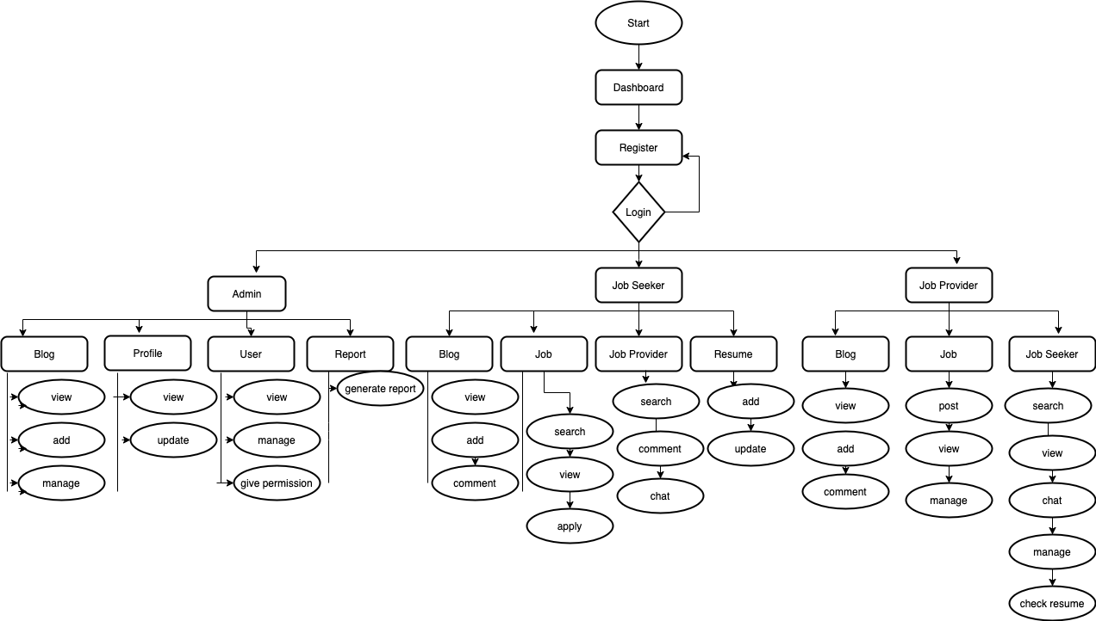

### Class Diagram

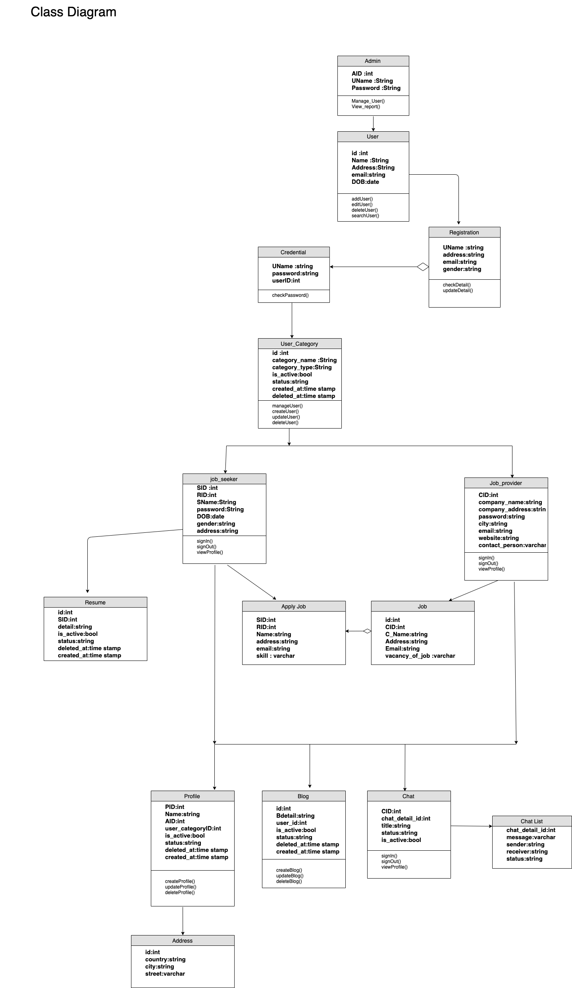

### ER Diagram

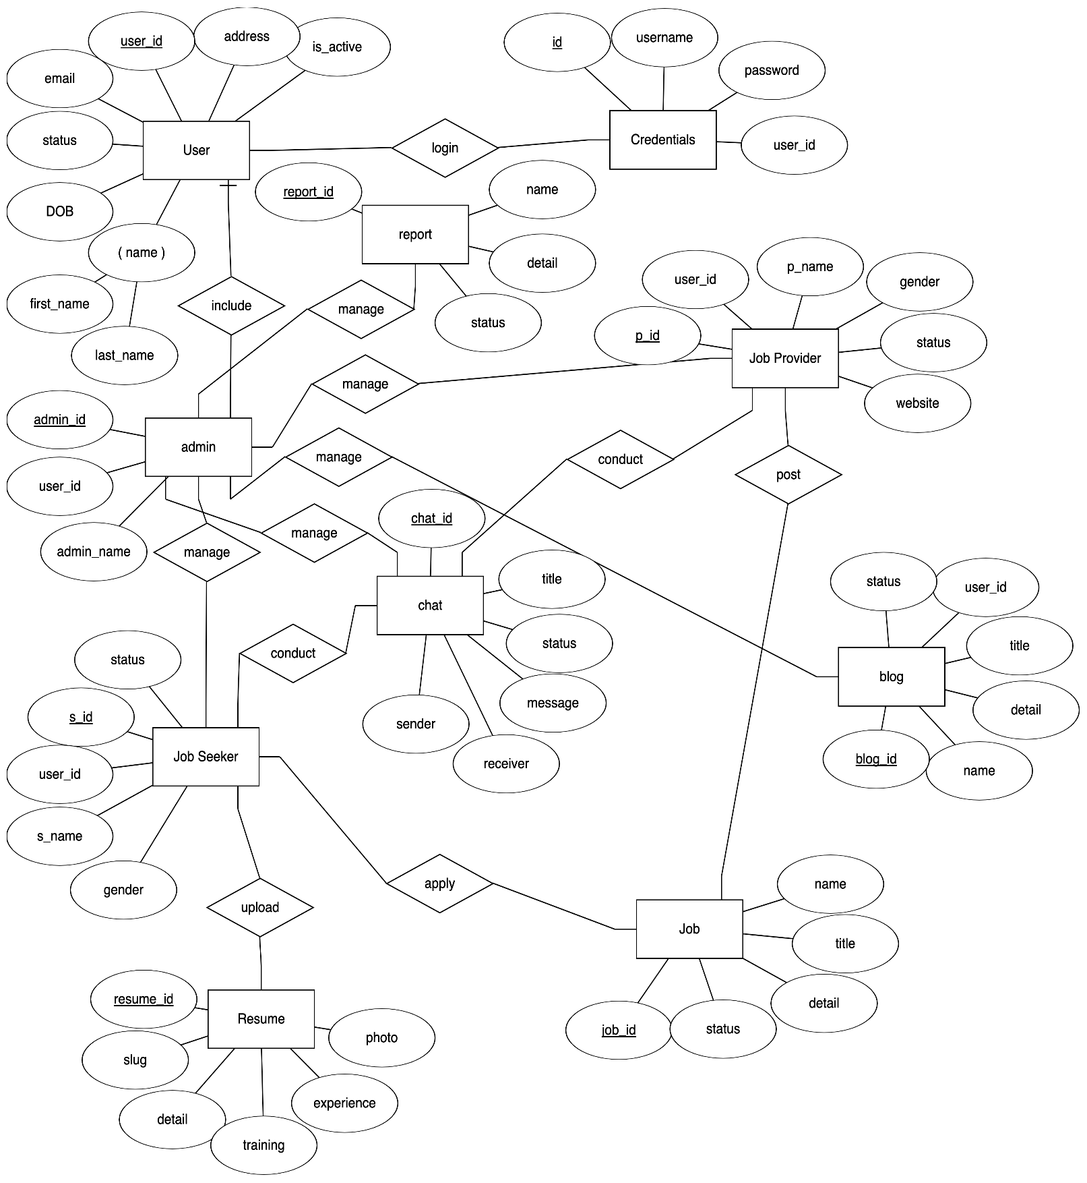

# Deliverables

Once the system is created, there are certain criteria it'll need to fulfil in order to be called a successful system. Although a system is never fully perfect and there is always room for improvement, there are some things that are basically expected after a system is created. Some of our targeted and expected outputs are:

1. It will provide a common platform for both job seeker and employer
2. It will be able to provide job and employer information according to the need of job seeker needs
3. It will also be able to provide a user guide for those user who don’t have knowledge about this system and also will provide tutorials to use the system.
4. It will provide security and real information

Time Schedule/ Gant Chart

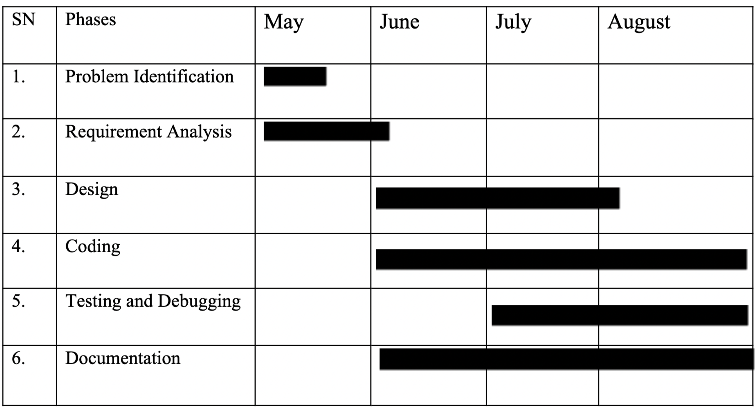

# Testing

Testing is a process of executing a program with the intent of finding bugs that make the application fail to meet the expected behavior. Regardless of the development methodology, the ultimate goal of testing is to make sure that what is created does what it is supposed to do. Testing plays a critical role in assuring the quality and reliability of the software. We have included testing as a part of the development process. The test cases should be designed with maximum possibilities of finding the errors or bugs.

We have designed and executed a few test cases to check if the application meets the functional requirements.

|  |  |  |  |
| --- | --- | --- | --- |
| TEST MODULE | TEST CASE | EXPECTED RESULT | TEST RESULT |
| ADMIN | Provide valid login credentials | User successfully logged in and directed to the admin dashboard page | PASS |
| ADMIN | Enters invalid login credentials | Displays Error message | PASS |
| EMPLOYER | Provide details for registration | Employer successfully registered with the application | PASS |
| EMPLOYER | Upon successful login, click on ‘Post New Job’ tab | Employer posts jobs with the required details | PASS |
| EMPLOYER | Employer clicks on the ‘List Posted Jobs’ tab | All the jobs posted by the employer will be displayed. | PASS |
| JOBSEEKER | Provide details for registration | Jobseeker successfully registered with the application | PASS |
| JOBSEEKER | Enters invalid login credentials | Error message displayed | PASS |
| JOBSEEKER | Upon successful login, click on ‘My Profile’ tab | List details of jobseeker | PASS |
| JOBSEEKER | Upon successful login, click on ‘Search Jobs’ tab | Details of the active job postings are displayed. | PASS |
| JOBSEEKER | Upon successful login, click on ‘Applied Jobs’ tab | Details of the jobs that are applied by the jobseeker are displayed | PASS |
| JOBSEEKER | Logout | Redirects to the Home page of the application | PASS |

# Documentation

As we did a requirement and feasibility analysis to find out the requirements our website is to fulfill and to check if it’s feasible or not. Then, we planned a layout for our website. Then, during the design phase, we created a blueprint of the system through DFDs, flowcharts, ER diagrams, class diagrams e.t.c. During the coding phase, we used HTML, Tailwindcss, JavaScript, jQuery for the front end and PHP for back-end development. A detailed description of each and every stage that has been carried out to complete this project is done in this report. The stage begins with a brief introduction to the project where the project’s aims, objectives, and expectations are noted down. Continuing this path, the background of the project is illustrated where the study and findings are related to the project. Likewise, in the design heading, the methodology used with the considered methodology is described.

# Conclusion

Job search portals are a revolutionary force in the recruitment industry. They facilitate communication between recruiters and applicants by mediating their needs. This tool facilitates a broad search for jobs that match job seekers' interests and gives employers more exposure to the candidate pool. The web development gives job seekers the freedom to explore openings and apply for employment without having to bring a laptop with them. Both employers and job seekers benefit from the improved user experience offered by this application. It has a user-friendly interface that makes it easier to reach many different audiences. All of the requirements that were initially established during the requirements gathering process have been met by the application. We picked up several IT best practices from this project.  We learned various best practices for the technological stack from this project. Working with diverse technologies at each stage, from requirements elicitation to design, construction, implementation, and testing has given us a great deal of experience. Our faith in web development has increased as a result of the development of this project

# Future Work

This project fulfills the primary requirements of job seekers and employers. It can be extended in several ways – We can provide recommendations and email updates for new job postings based on the job seeker’s search history. Since, job seekers might be interested in building a strong Resume, we can provide tips and information for the same. We can also provide templates for building the Resumes which might interest most applicants. The web developed fulfilling the functionalities of job seekers, it can be extended to support the functionalities of Employers as well

# References

[1] [Shelady Anne Quinto](https://www.scribd.com/user/30723338/Shelady-Anne-Quinto) , Project On Job Portal,

[http://www.scribd.com/doc/46691636/Job-Portal-Reference](http://opus.govst.edu/capstones/154)

[2] SOWMYA MATHUKUMALLI B. Tech., SASTRA University, India, 2014 from KANSAS STATE UNIVERSITY Manhattan, Kansas [http://core.ac.uk/download/pdf/77979433.pdf](http://money.howstuffworks.com/how-inventory-managementsystems-work1.htm)

[3] [Deepak](https://projecttunnel.com/user/vO9JiY-10) from MP NAGAR BHOPAL

[http://projecttunnel.com/online-job-portal-project-in-php-document](http://opus.govst.edu/capstones/154)

[4] More Sushant Shantanu Nikam Satyajit Sunil Shinde Sayali Vijay Suryawanshi Yashashri J.

[https://www.scribd.com/document/397114252/Online-Job-Portal-Using-PHP-MySQL-Project-Full-Report](https://www.scribd.com/document/3971142531bestcsharp.blogspot.com)